UPC/HSC FPM EVENTS PLANNING
3450 S. Vermont, LA CA 90089-2590, FPM 100
Please submit completed checklists to: fms-evtp@usc.edu
FPM EVENTS PLANNING CHECKLIST FY24
THINGS TO KNOW:
1. Anything less than two weeks' notice cannot be guaranteed and will be charged a $175 late fee.
2. Checklists submitted after 3pm on Friday will be considered received the following business day (Monday). Point #2 takes effect on Monday for checklists received after 3pm on Friday. Please note, the FPM Events Office is closed on weekends.
3. FPM Events no longer handles rental requests for tents, tables, chairs, chain link fencing, microphones, etc. The customer should contact a 3rd party vendor directly. The Events office can provide vendor information as requested.
4. FPM Events will continue to provide trash/recycle boxes, standards, vinyl fencing, electrical services, custodial services, landscape services, move-jobs, bicycle rack removals, Zero Waste assistance as well as other services. The Events office can assist with any questions.
5. A deposit is required for checklist processing. Please see page 6 for further details.
6. Please see pages 7 & 8 for Zero Waste Information.

EVENT INFORMATION - *Required
Name of Event: | *
Event Permit Number: | *
Location(s): | *
Date(s) of Event: | *
One-Line Event Description: | *
Number of Attendees : | * | Number? _______ Is Food Being Served? Yes____ No____
NOTE: If “Yes” to above question, please answer (Section/s 2 and 3) on Page 2 of this document.

EVENT TIMES - *Required
 |  | Day |  | Date |  | Time
Event Setup: | *
Event Begins: | *
Event Ends: | *
Event Breakdown: | *
EVENT CONTACT INFORMATION - *Required
Name: | *
Address: | *
Telephone #: | *
Cell Phone #: | *
Email: | *
Supervisor/USC Org. Contact: | * | Name: Cell #:

FPM SERVICES
1. AIR CONDITIONING/HEATING (Indoor Facilities)  No Charge - For informational purposes only |  |  |  |  |  |  |  |  |  |  |  |  | “X” if Services Requested
NOTE: Unless AC is requested here, there is the possibility that the AC will not be on. A charge of 4-hours overtime or $505.00 may apply for calls that are made the day of the event to adjust temperature that is not scheduled.
LOCATION(S):  Be specific (Building name and room number, lobbies, floors, etc.) Multi-sites. |  |  |  |  |  |  |  |  |  | Dates/times: |  |  |  |  | Building/Room Number(s):
 |  |  |  |  |  |  |  |  |  | On:
 |  |  |  |  |  |  |  |  |  | Off:
2. CUSTODIAL INDOOR CLEAN-UP MANDATORY FOR ALL INDOOR EVENTS  $40.30 per hour – Overtime may be required due to day and time of event |  |  |  |  |  |  |  |  |  |  |  |  | “X” if Services Requested
Service |  |  |  |  |  |  |  |  | Date(s) |  | Time(s) |  | Specific Location(s)
Pre-Event Clean-up:
(Trash removal, floor care, dusting, cleanup/restocking of restrooms, etc.)
Post-Event Clean-up (Restrooms also included): (Required for indoor events with food and/or trashcans) May require overtime depending on day and time of cleanup. Ask about Zero Waste.
Mid-Event Restroom Cleanup:
(Cleaning and restocking on a scheduled basis) i.e.,
Clean up at 2:00pm, 4:30pm, 6:00pm
Standby Custodian___ Police restrooms___ (On-site at all times, or may check restrooms throughout the event at specific intervals)
Custodial Assistance with Zero Waste
NOTE: Cleanup of the restrooms in ADM, and cleanup of dressing rooms in BOVARD are not included in your rental contract with Trojan Event Services. A separate request to FPM must be made. Please contact our office or your planner for more information.
3. LANDSCAPE - OUTDOOR CLEAN-UP – ZERO WASTE  MANDATORY FOR ALL OUTDOOR EVENTS: TROUSDALE, CHILDS WAY, PARKS |  |  |  |  |  |  |  |  |  |  |  |  |  | “X” if Services
 |  |  |  |  |  |  |  |  |  |  |  |  |  |  |  | Requested
$44.70 per hour – |  |  |  | Overtime required for weekend or after hours (After 4pm M-F)
Diagram Required |  |  |  |  |  |  |  |  | Date |  | Time |  | Specific Location(s)
Pre-Event Clean-up |  |  | (Litter cleanup, empty bins,
 | M-F by 11am). If need wash, leaf blow/rake,
 | completed by 7am.
Post-Event Cleanup – |  |  |  | (Required for all events with
 | food). Note: Any request for after 4pm will be
 | completed early the following morning |  |  |  | .
Boxed Lunch (Indicate with an X next to yes/no) |  |  |  |  |  |  |  |  | Yes: |  | No:
Hose/Spigot needed (Indicate with an X next to yes/no) |  |  |  |  |  |  |  |  | Yes: |  | No:
4. ATHLETIC FIELDS: $48.80 per hour –  After 1:30pm, overtime rates apply. |  |  |  |  |  |  |  |  | Date |  | Time |  | Specific Location(s)
Special Requests- Pre-Event Clean-up: (Wash down, reline trashcans, rake leaves, grandstands, etc. clean up of fields, trash).
Post-Event Cleanup
(Mandatory for all events with trashcans/food)
Zero Waste Event? (See pg 7 & 8) Yes: No:
FPM SERVICES
.
5. ELECTRICAL SERVICES: $82.30 per hour | **Diagram required with electrical locations |  |  | ** |  |  | “X” if Services Requested
Note: Job Walk is preferred for all large events.
Electrical Circuits:  Based on Power Use and Electrician Recommendation (120V – 20 amp circuits)  *additional power upon request. |  | Amount | Location |  | Set up Date/Time |  |  | Breakdown Date/Time
MANDATORY:  Please List ALL Electrical Needs:  - Indoor lighting for tent/ outdoor lighting  - Sound& Speaker Connections  - Fans/Misters/heaters  - Catering (coffee maker, refrigerator, popcorn machines)  - Other (TV’s, Porta-Restrooms, computers)  Note:  - Electrical Information must be supplied before the event.  - Vendors are not allowed to plug into university power outlets –No Exceptions |  | List all items that will require power:
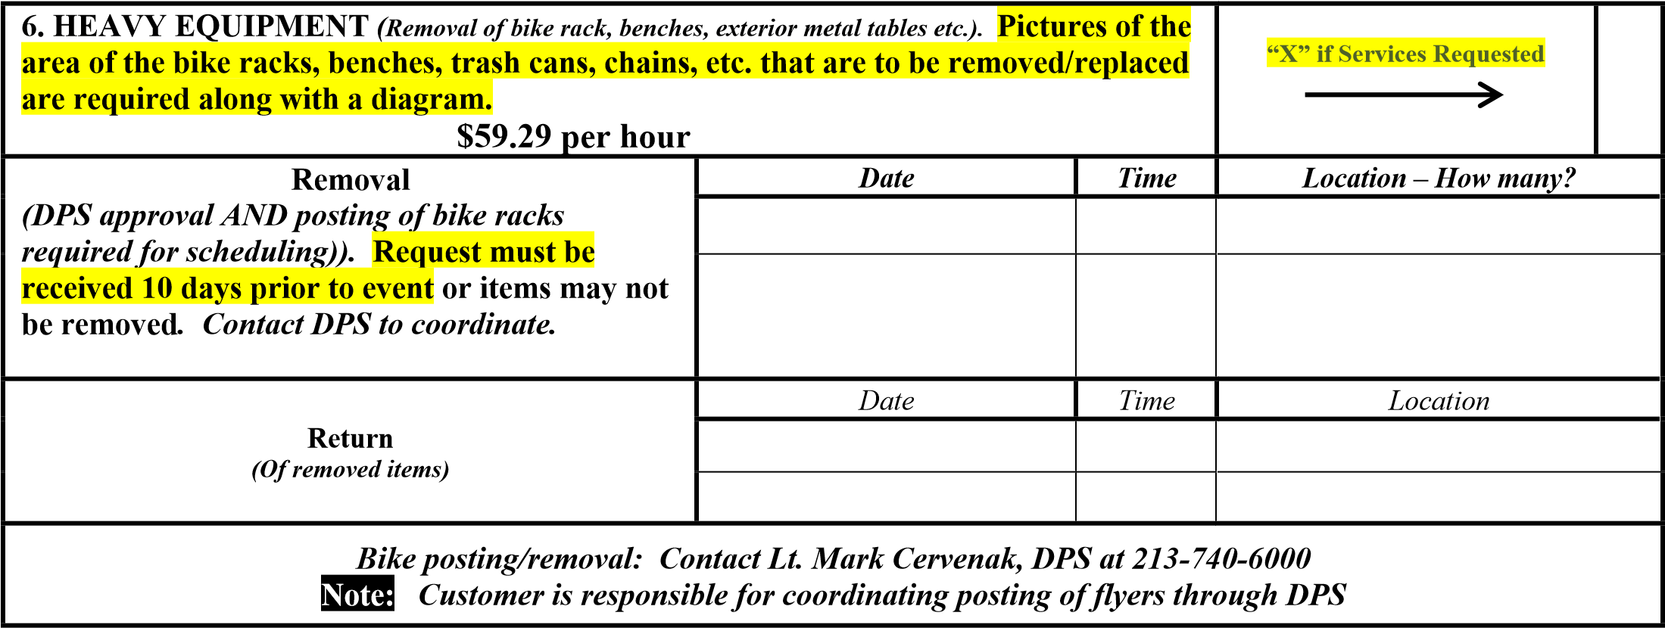
7. FOUNTAIN REQUESTS – ****Fountain Daily Normal Operations 7AM – 7PM*****  $62.30 per hour |  |  |  | “X” if Services Requested
Fountain Off/ON | Date | Time OFF | Time ON | Fountain Location/s
Fountain Turned Down | Date | Time DOWN | Turn on Normal | Fountain Location/s
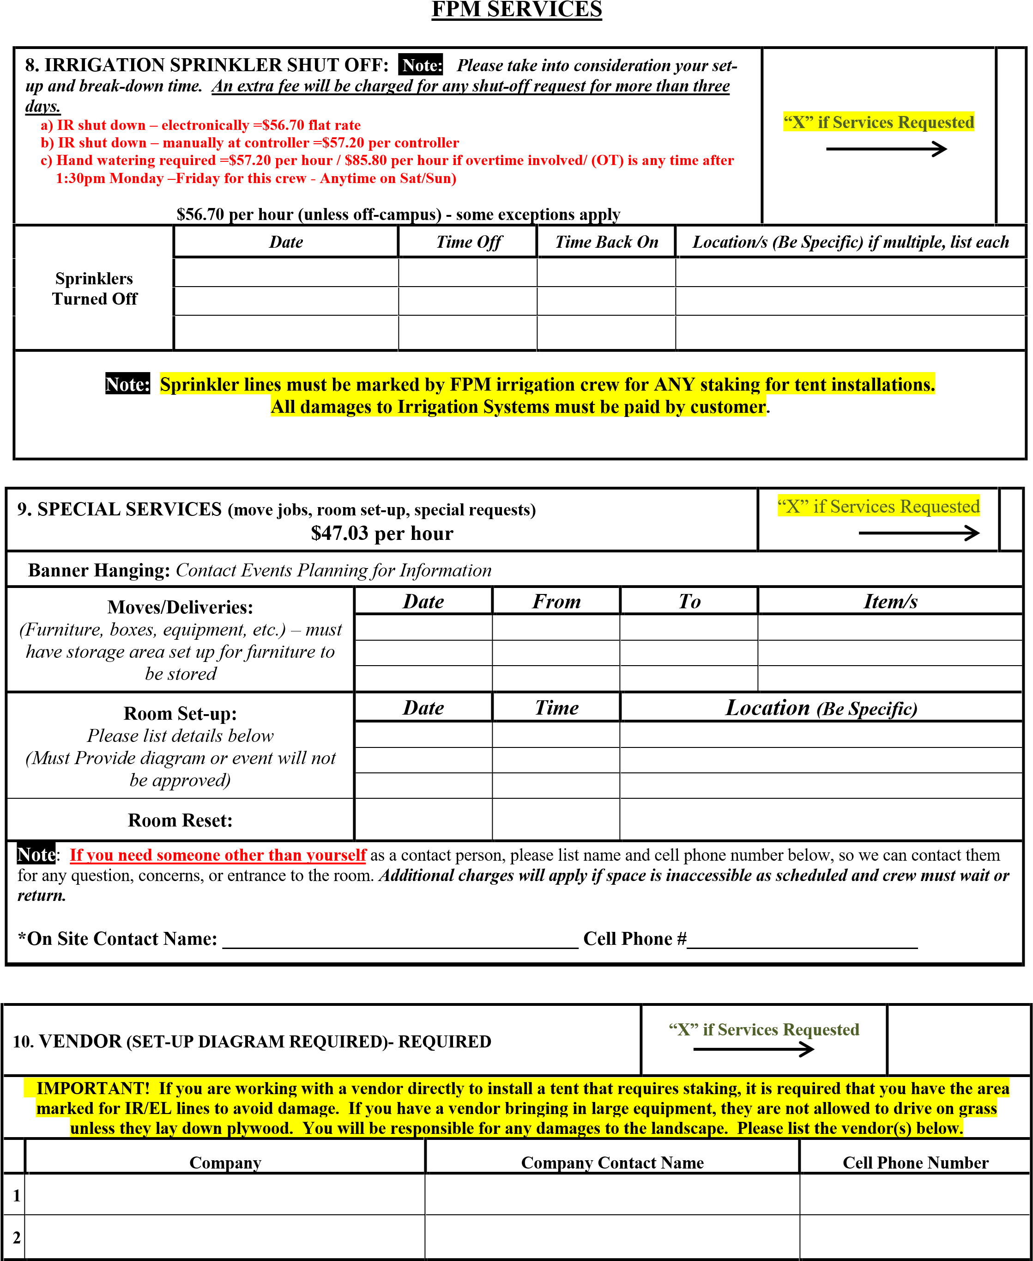

FPM EQUIPMENT RENTALS
Note:

DROP-OFF/PICK-UP INFORMATION MUST BE ENTERED OR YOUR CHECKLIST
WILL BE RETURNED AND WILL NOT BE PROCESSED
!

ces

“
X” if Servi
d
Requeste
•
All equipment rentals require minimum delivery fees. Please call us to inquire about fees concerning: timed delivery rates,
before and after hours’ delivery, and weekend delivery.
•
We must be
Notified Immediately
of any equipment missing at delivery by calling
213-740-6833
.
NO

After-the-Fact Credit

will be
given. Missing or damaged equipment upon pickup (standards, podiums, hoses, quick couplers) will be charged back to the
requestor/customer.

•
We do not recommend leaving equipment out overnight or on weekends.
*
Date
*
Time
*
Location
OFF
DROP-

Include a 4-hour window to save
(
on delivery fees)
PICK-UP

:
Include a 4-hour window to save
on pick up fees)
RENTAL ITEMS |  |  |  |  | COST | QTY | ADDITIONAL NOTES
FPM White Vinyl Fencing (10’ x 4’ panels) (plus delivery) |  |  |  |  | $22.50 |  | Price per panel plus delivery. Does not include set up.
FPM Flag (California) (plus delivery) |  |  |  |  | $45.00 |  | Customers are responsible for flags if damaged, lost or stolen
FPM Flag (USA) (plus delivery) |  |  |  |  | $45.00 |  | Customers are responsible for flags if damaged, lost or stolen. $175.00 - replacement charge
FPM Flag Stands (plus delivery) |  |  |  |  | $7.50 |  | Inserts may be required
 | CRUE President’s Podium – Must Check or Circle One |  |  |  | --------- |  |  | Approval REQUIRED. Please email: adamr@usc.edu
 | Wooden_______ Acrylic______ (plus delivery) |  |  |  |  |  |  | Must provide Podium placement on diagram.
 | FPM Podium – No Seal. Must Check or Circle One |  |  |  | $85.00 |  | Must provide Podium placement on diagram.
 | Wooden_______ Acrylic______ (plus delivery)
FPM Sign Standards – White Wooden 6’ high (plus deliver |  |  |  | y) | $15.00 |  | ($100.00 fee for each lost or damaged item ) Will be counted on pickup. If not at specified pickup location, additional charges will apply.
FPM Trash boxes, (Black) – (need sorting assistance ? As your Planner |  |  |  | k | $10.00 |  | Delivery extra – Set up with 1 liner unless additional requested.
FPM Compost boxes (Green) – (plus delivery) (need sortin – See Zero Waste Information on page 7 and 8 |  |  |  | g | $10.00 |  | Delivery extra – Set up with 1 liner unless additional requested.
FPM Recycle boxes, (Blue) - (plus delivery) sorting needed – See Zero Waste Information on Page 7 and 8 |  |  |  |  | $10.00 |  | Delivery extra – Set up with 1 liner unless additional requested.
FPM Clear Liners for Trash, Recycle, Compost boxes |  |  |  |  | $0.60 |  | 1- liner for each box, unless additional requested.

VENDOR INFORMATION FOR RENTALS
FPM Events longer has the resources to provide the coordination for material and equipment services with third party vendors. To receive services that include items, such as tents, chairs, tables, chain-link fencing, portable restrooms and so on, we encourage you to contact the vendor directly for services they can provide. The following are approved vendors:
Bright | Town and Country | Pronto Janitorial | 1st Jon Rentals
USC@bright.com | lchen@tacer.biz | 213-905-5322 | 877-566-8646
310-202-0011 | snega@tacer.biz | WORK_ORDERS@PRONTOJSI.COM | www.1stjon.com
Pricing for vendor services has gone up significantly recently and may differ depending on a variety of factors, such as delivery date and time, and services requested. Please contact the vendor directly with your specific needs for accurate pricing.
Please note the following vendor and customer responsibility:
- There are to be no materials, metal, or other dangerous objects, left at any sites from breakdown of their rentals - especially tenting (i.e., bolts, pipes, metal connectors, etc.). The site must be left in a condition that is satisfactory to USC.
- When spiking for tenting or canopies, the customer must contact FPM events to schedule a service with the Irrigation shop to mark areas to avoid where irrigation piping exists.
- Customer will need to work with FPM Events to have access to power to operate rental items that requires power (i.e., string lighting). The use of university electrical without authorization or clearance from USC Facilities is prohibited.
- Vendor is to use only specially wrapped wire or rope for hanging sails, lighting, banners, or other objects to trees. Vendor must also install a special protection cloth between the tree and the attached wire or rope to ensure there is no damage to trees.
- Vendor is not allowed to drive onto lawn areas at any time without appropriate protection like plywood placed under the vehicle/truck.
Vendor/customer will be responsible for any damage caused to landscaping.

EVENT SIGNATURE AND PAYMENT APPROVAL
*** We require a cell phone number for deliveries. If the requestor cannot be contacted, a message will be left on the cell phone for confirmation and a photo taken of delivered item(s). FPM is not responsible for missing or damaged items once rentals are delivered. YOU OR A SUBSITUTE SIGNER MUST SIGN FOR ALL DELIVERIES.
PAYMENTS FOR YOUR EVENT: A deposit Requisition (IR) of $250 is required to process your checklist. As soon as your checklist is received, we will provide you with a work order number to process your REQ deposit in Workday. Please use this checklist as your documentation for this REQ requirement. Please use ISP 029 for Events in Workday. The REQ will not be charged until after you receive a final invoice from your planner. Please note, the requested services will not be scheduled until the deposit REQ information is provided and verified approved in Workday.
If you do not have access to Workday, we will accept a check payment. Please note, the check payment must be received prior to the event date, or your services will not be scheduled. Please process and deliver your check as follows:
FPM, 3450 S. Vermont Ave, LA, Ca 90089 Att: Norman Antonini
Please make your check out to: Facilities Planning and Management, CO your Planner and include work order number on memo line.
Requester Signature: Date: ____ _______
By signing, you acknowledge responsibility for all policies and services requested on this checklist, including payment for services.

PLANNING YOUR ZERO WASTE EVENT
WHY MAKE YOUR EVENT ZERO WASTE?
President Folt has set a goal to reach Zero Waste by 2028 and events have a role to play in achieving this goal. Zero Waste means diverting 90% of waste from a landfill through methods such as reusing, composting, recycling and donating leftover food.
Zero Waste helps us live in harmony with the planet and is beneficial to the planet, ourselves and to future generations. As many people have said throughout time, “We do not inherit the Earth from our ancestors, we borrow it from our children”.
PRE-EVENT CHECKLIST
Minimizing landfill waste from your event involves important steps. Apart from requesting items or services through FPM Events, you will need to…
- CONTROL THE INPUTS to your event by using reusable or compostable products. Reducing waste at your event starts with controlling the waste you generate at your event, to prevent waste before it starts.
a. Compostable items are still single use and should be a considered a secondary option to reusables
b. | IF YOU PURCHASE COMPOSTABLE ITEMS CHOOSE WOODEN AND/OR FIBER
 | BASED ITEMS. THESE HAVE THE HIGHEST CHANCE OF BEING COMPOSTED
- EDUCATE YOUR GUESTS on proper waste sorting to ensure waste is properly disposed of. Use your event to help educate the USC community on how to be more sustainable.
- NOTIFY caterers ahead of time of the expectation to donate leftover food or supply reusables. Include verbiage about the event being zero waste when participants register for your event.
- RETHINK YOUR SWAG Most swag found at events are only used for a short amount of time before being disposed of. Opt for items that are recyclable or compostable. Even better, avoid giving items and invest that money in using reusable serveware.
After ensuring that the materials at your event are reusable and/or compostable and planning how to educate your guests, please use the remainder of this checklist to request the proper items and services to ensure waste from your event is properly diverted from landfill.
Zero Waste is evolving on campus and procedures outlined here are subject to change.

Zero Waste (Services to Review for Zero Waste Events) | Post Event Clean up must be requested in section FPM Services 3
Service
1) Event Boxes (# of compost, recycle & trash)  - Every 50 people you need 3 compost, 1  recycle & 1 landfill  - If catered, you need 1 additional set of compost, recycle and landfill boxes. To be used by caterers only (back of house). | ____ Compost  ____ Recycle  ____ Landfill
2) Number of Zero Waste Stations  - These are required centralized locations for your event boxes  - Every 50 people you need 1 Zero Waste  Station  - Dependent on the space you’re using | Number of stations ____
3) Sorters  - Staff to direct attendees of proper disposal at the Zero waste Stations  - This is not required, but will eliminate potential contamination | ____ Sorters (Dependent upon availability)
4) Relining Boxes  a) Every 1 hours boxes will be serviced (if there are no sorters at the event) | ____ Length of Event
5) Plates, Cups, Utensils, Napkins, Etc.  a) Send physical samples or pictures to Zero Waste Team pre-event | ____ Sent Samples?
6) COMMERCIAL COMPOST DUMPSTERS ($155.10 per bin and $93.70 per disposal). Mandatory for  Zero Waste events with over 50 guests  a) Rates are subject to change | ____ (# of temp compost bins)
7) Donations | Inform caterers of the expectation to donate leftover food from your event
*The Zero Waste Team will follow up with a call to discuss

